Jordan Brooks Adams - Biography

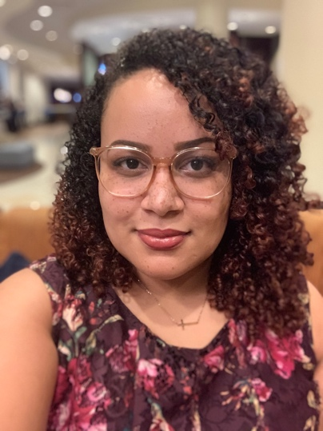
Jordan Brooks Adams considers it her life’s work to serve, lead and empower people and communities for social, health, and economic equity. Born and raised in the urban core of New Haven, CT, Jordan is familiar with the plight of disenfranchised and underserved communities, and uses her personal experiences as inspiration and a launching board for connecting with community members. Jordan loves listening to the stories of community members, and believes in making their voices heard in order to generate positive community change. Additionally, she has an eye for the big picture and develops strategy to make vision become reality.

Prior to joining the West Boulevard Neighborhood Coalition, Jordan worked with large and small nonprofit and community organizations to improve health and educational outcomes for community members. Her strategy initiatives include implementing systems of training and development and organizational restructuring. With a mind for making data relevant, she has developed data collection and management systems, and makes the data come alive in report writing and policy analysis. Jordan is also a business consultant and brand developer, and has guided the launch of small businesses and ministries throughout the United States.

Jordan received her Bachelor of Arts from Columbia University, Master of Arts from Yale University, and is working towards her Ph.D. through the University of Missouri-Kansas City in Public Affairs and Administration. The focus of her research is on reducing complex mental health stigma among religious African Americans through community development approaches. As a researcher and public servant, Jordan has kept a foot in both worlds of community service and academia, which has shaped her research paradigms, practical knowledge, and service orientation.

Jordan’s love for people is evident in her community service and ministry partnership with her husband, Kameron. In her free time, Jordan enjoys spending time with family and friends; cooking and baking; crochet; and getting lost in a great book.

